
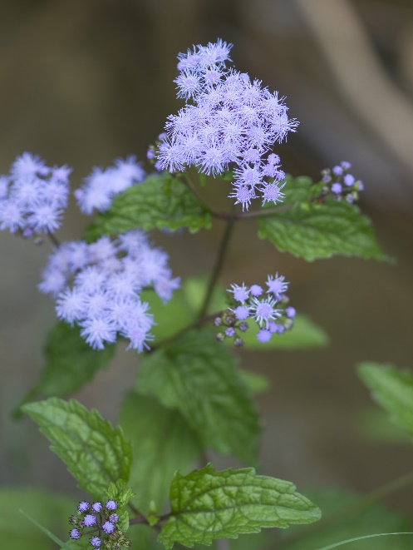

Blue Mistflower
Conoclinium coelestinum
Nectar Plant

Native to Alabama

