
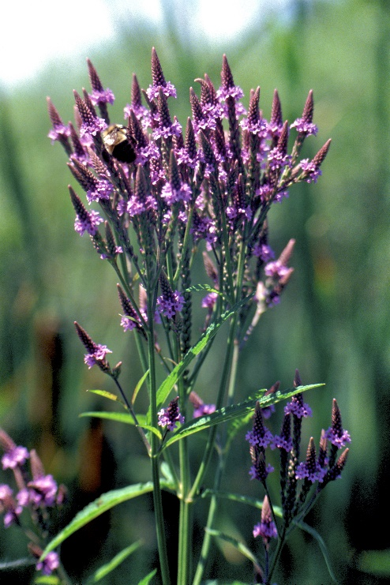

Blue Vervain
Verbena hastata
Nectar &
Host Plant

Native to Alabama

