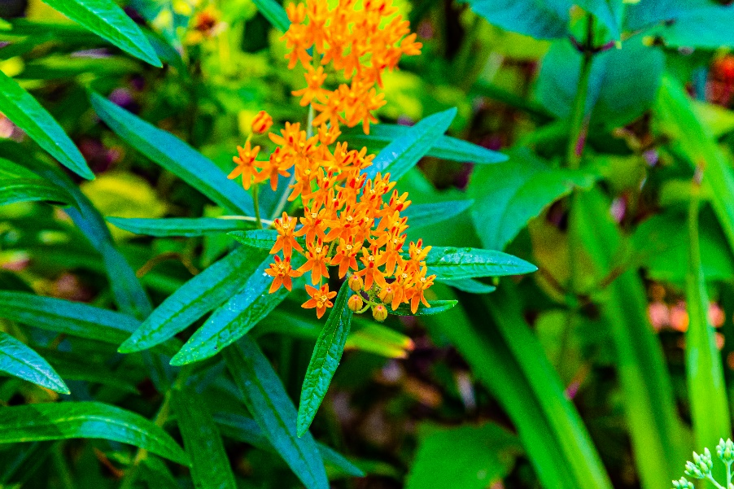

Native to Alabama
Butterfly Milkweed
Asclepias tuberosa
Nectar &
Host Plant

