
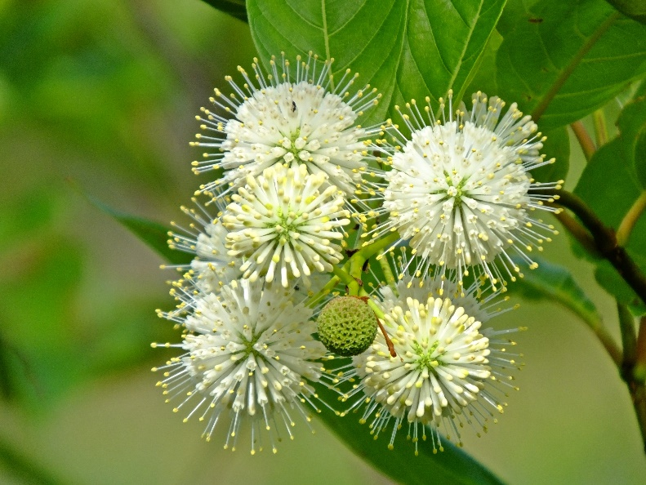
Buttonbush
Cephalanthus occidentalis
Shelter & Food
for Birds

Native to Alabama

