
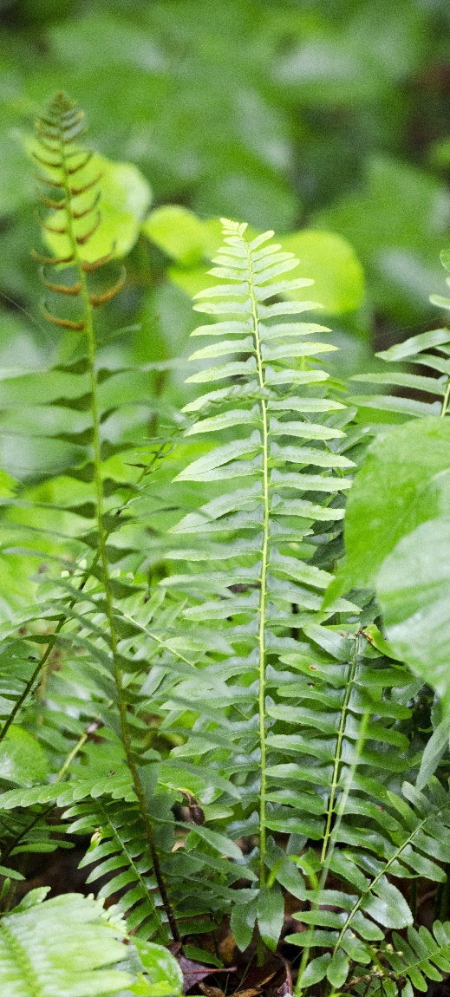

Native to Alabama
Christmas Fern
Polystichum acrostichoides
Shade Plant

