
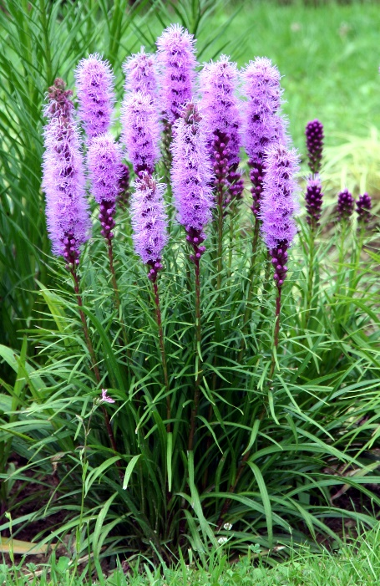

Dense Blazing Star
Liatris spicata
Nectar Plant

Native to Alabama

