
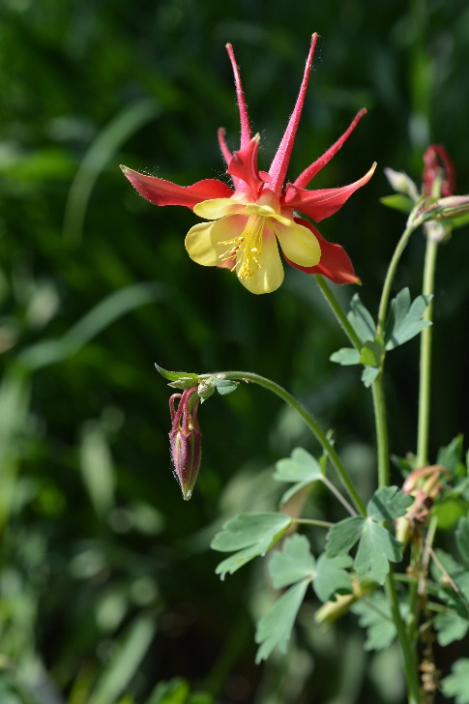
Eastern Red Columbine
Aquilegia Canadensis
Nectar Plant

Native to Alabama

