
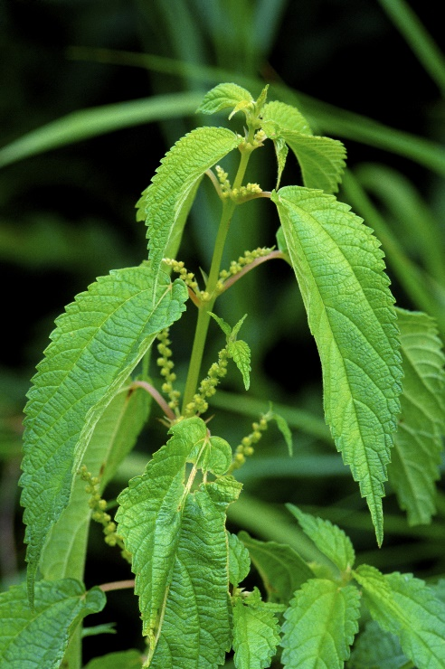
False Nettle
Boehmeria cylindrica
Host & Nectar
Plant
Native to Alabama

