
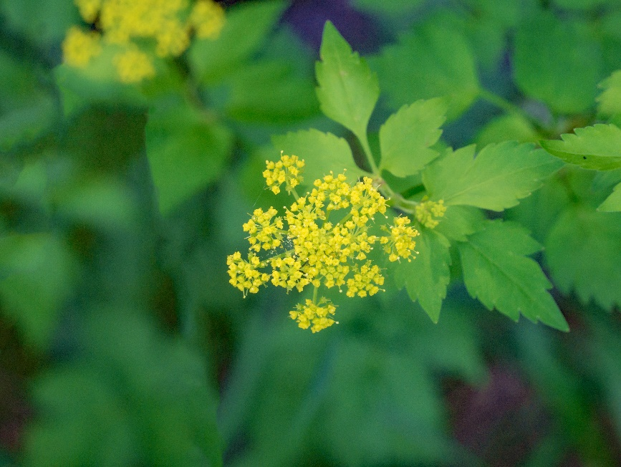
Golden Alexander
Zizia aurea
Host & Nectar
Plant
Native to Alabama

