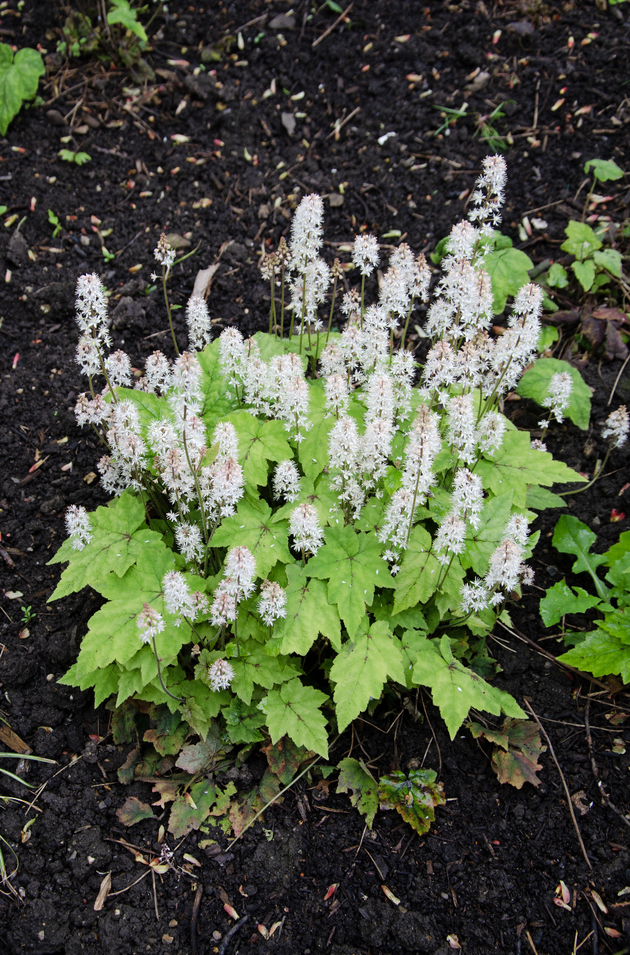


Heartleaf Foamflower
Tiarella cordifolia
Nectar &
Cover Plant

Native to Alabama

