
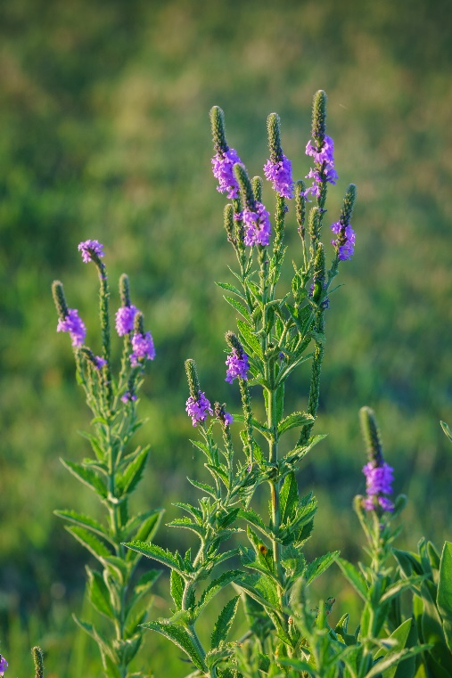

Hoary Vervain
Verbena stricta
Nectar &
Host Plant

Native to Alabama

