
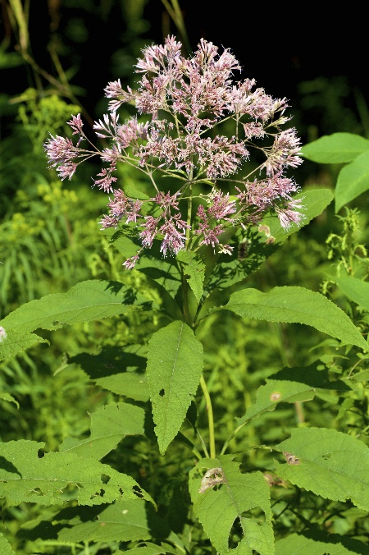

Joe-pye Weed
Eutrochium fistulosum
Nectar & Shade Plant

Native to Alabama

