
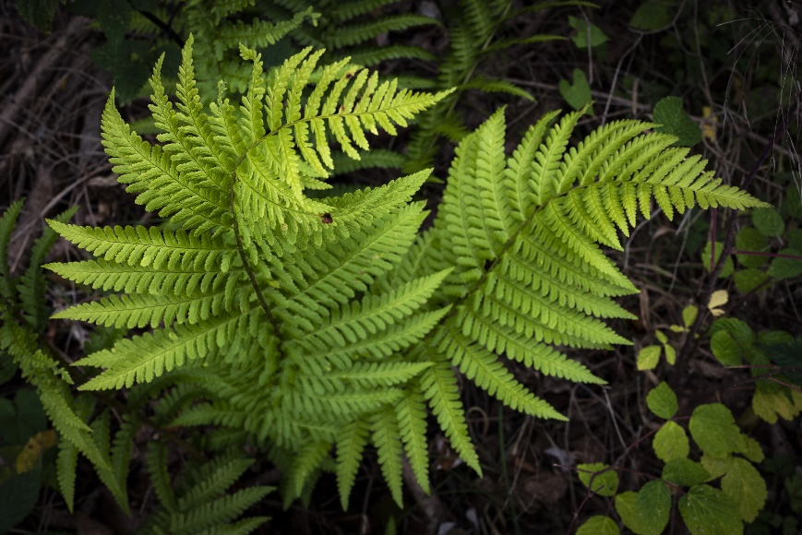

Lady Fern
Athyrium filix-femina
Shade Plant

Native to Alabama

