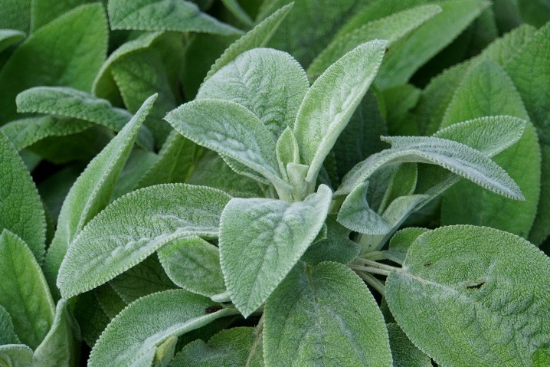


Lamb’s Ear
Stachys byzantina
Touch My Leaves

Non-
native

