
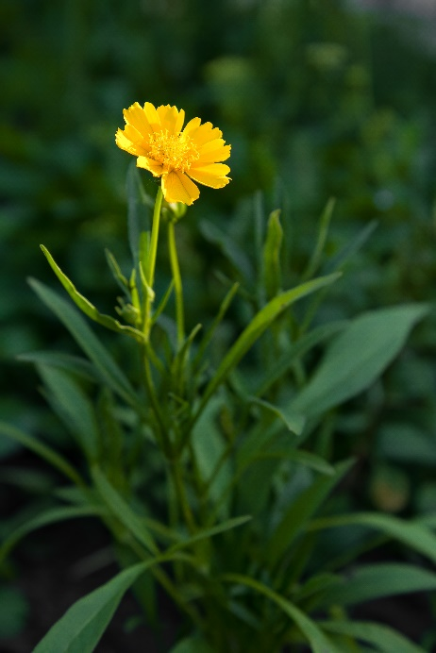
Lanceleaf Tickseed
Coreopsis lanceolata
Seeds &
Nectar Plant

Native to Alabama

