
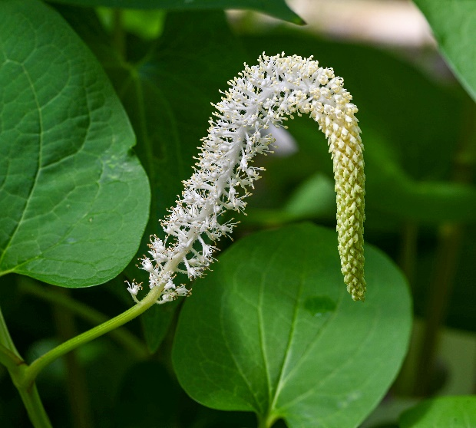

Lizard’s Tail
Saururus cernuus
Aquatic Plant

Native to Alabama

