
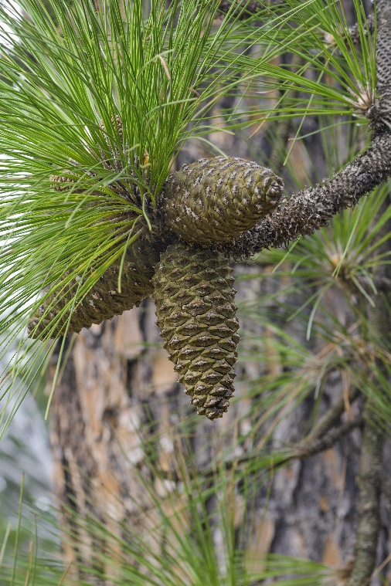
Longleaf Pine
Pinus palustris
Alabama’s State Tree

Native to Alabama

