
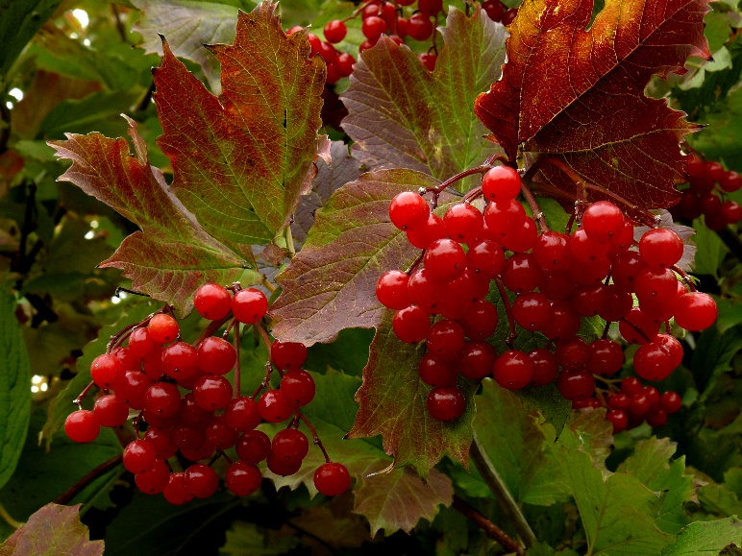

Mapleleaf
Viburnum
Viburnum acerifolium
Shelter & Food
for Birds

Native to Alabama

