
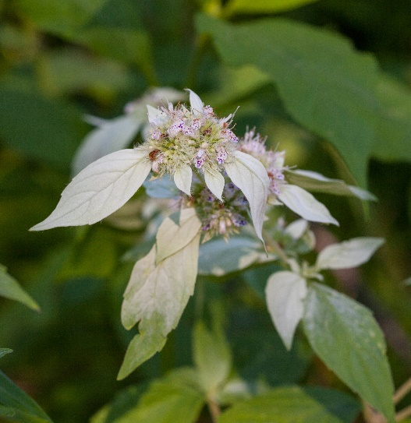

Mountainmint
Pycnanthemum incanum
Taste Me

Native to Alabama

