
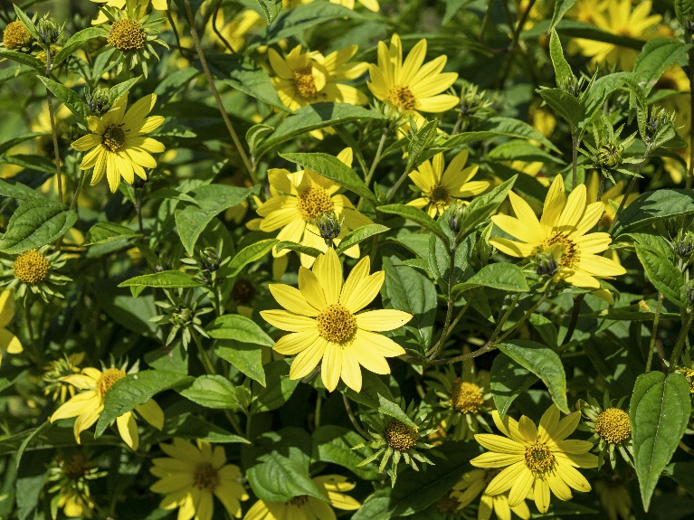
Native to Alabama
Narrowleaf Sunflower
Helianthus angustifolia
Seeds &
Nectar Plant

