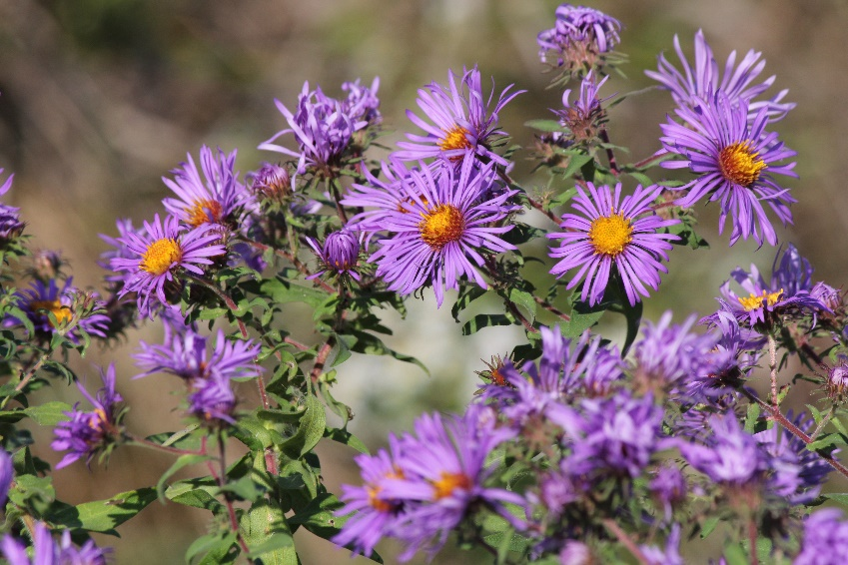


New England
Aster
Symphyotrichum novae-angliae
Host & Nectar Plant

Native to Alabama

