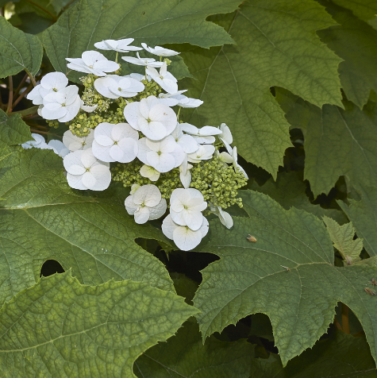


Oakleaf
Hydrangea
Hydrangea quercifolia
Shelter for Birds

Native to Alabama

