
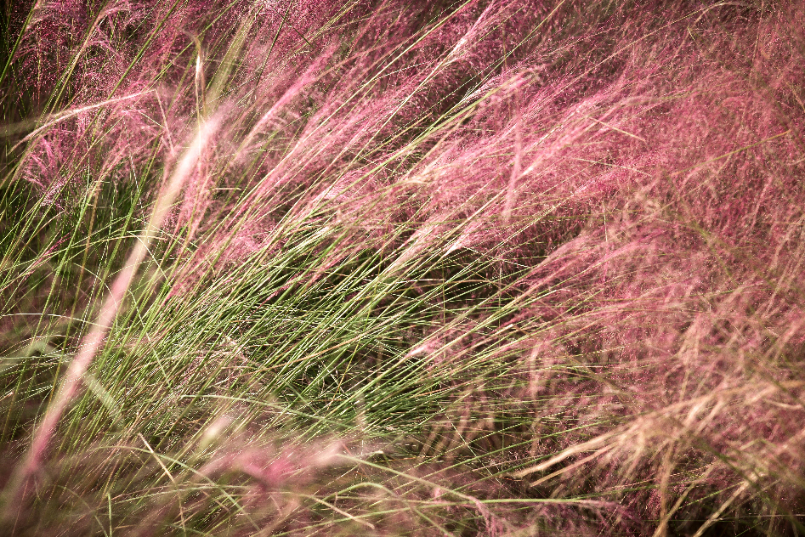
Pink Muhly Grass
Muhlenbergia capillaris
Food for Birds

Native to Alabama

