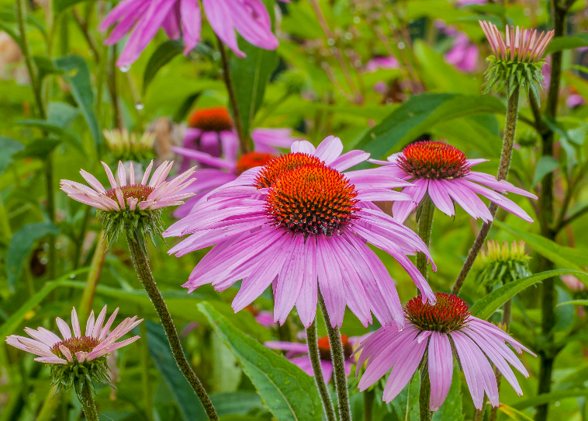


Purple Coneflower
Echinacea purpurea
Seeds & Nectar
Plant

Native to Alabama

