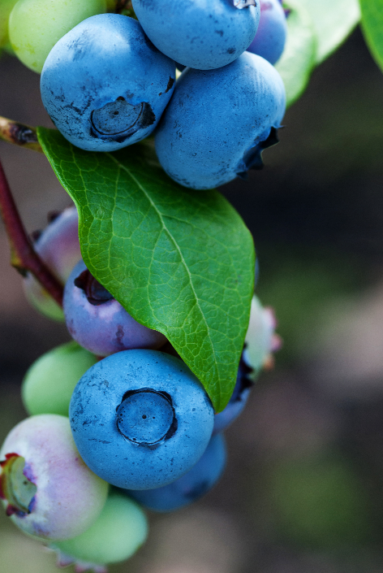

Rabbiteye Blueberry
Vaccinium virgatum
Food for Birds
Native to Alabama

