
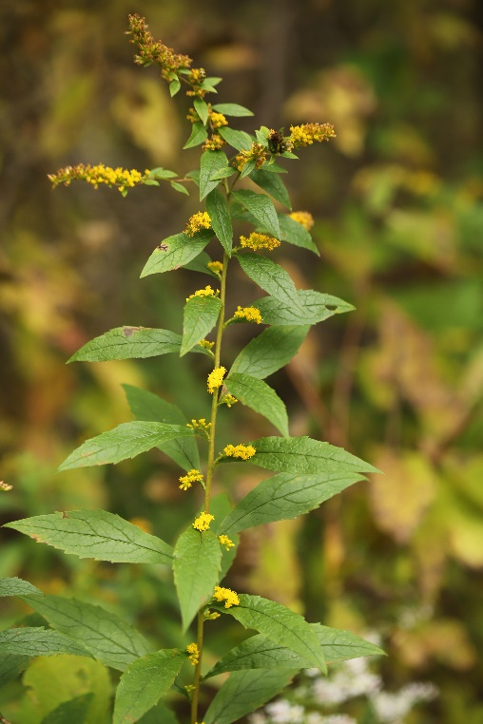

Roughleaf Goldenrod
Solidago rugose
(Similar to Showy Goldenrod)
Nectar Plant

Native to Alabama

