
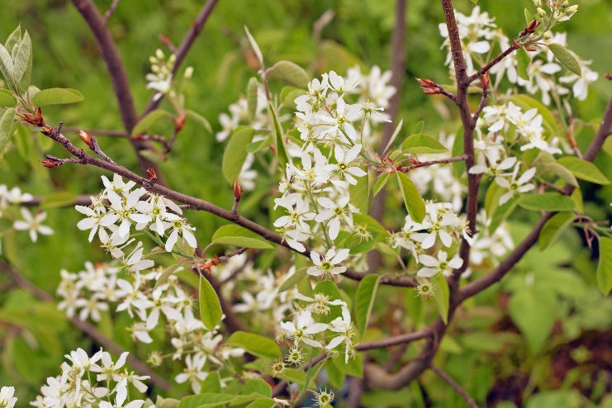

Serviceberry Tree
Amelanchier canadensis
Shelter & Food
for Birds

Native to Alabama

