
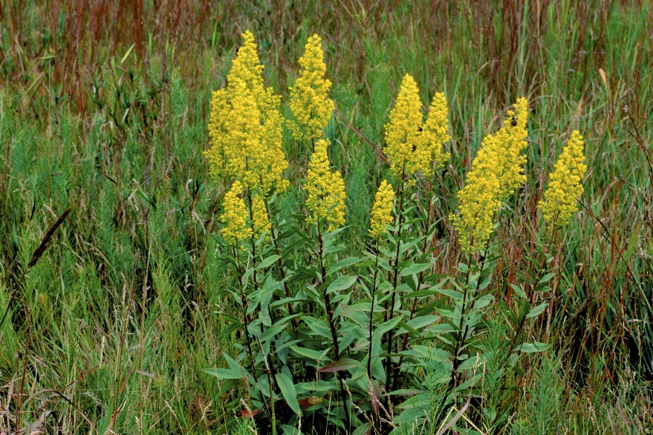

Showy
Goldenrod
Solidago speciosa
Nectar Plant

Native to Alabama

