
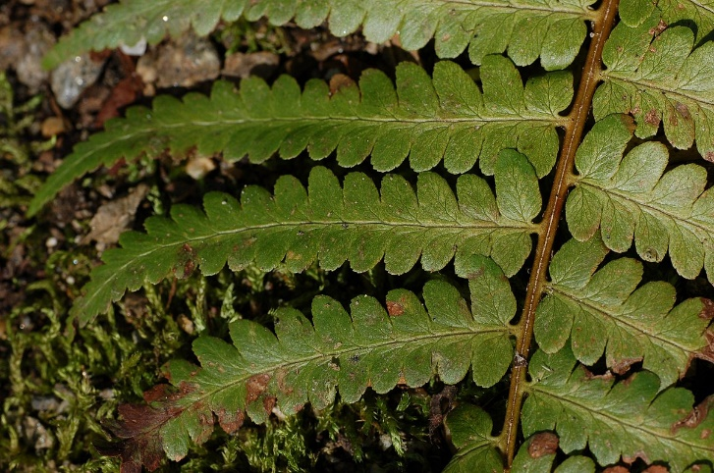

Southern
Woodfern
Dryopteris ludoviciana
Shade Plant

Native to Alabama

