
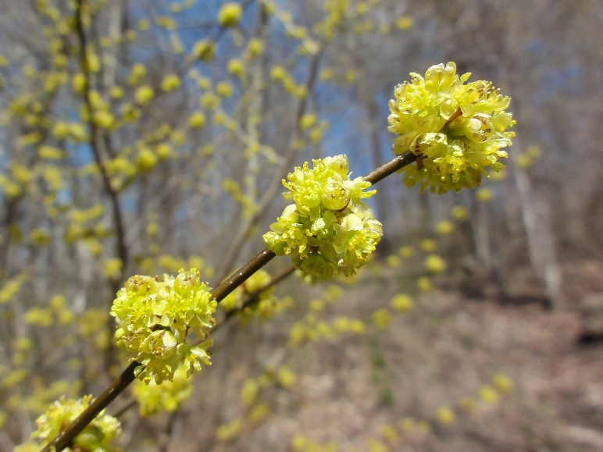

Spicebush
Lindera benzoin
Nectar &
Host Plant

Native to Alabama

