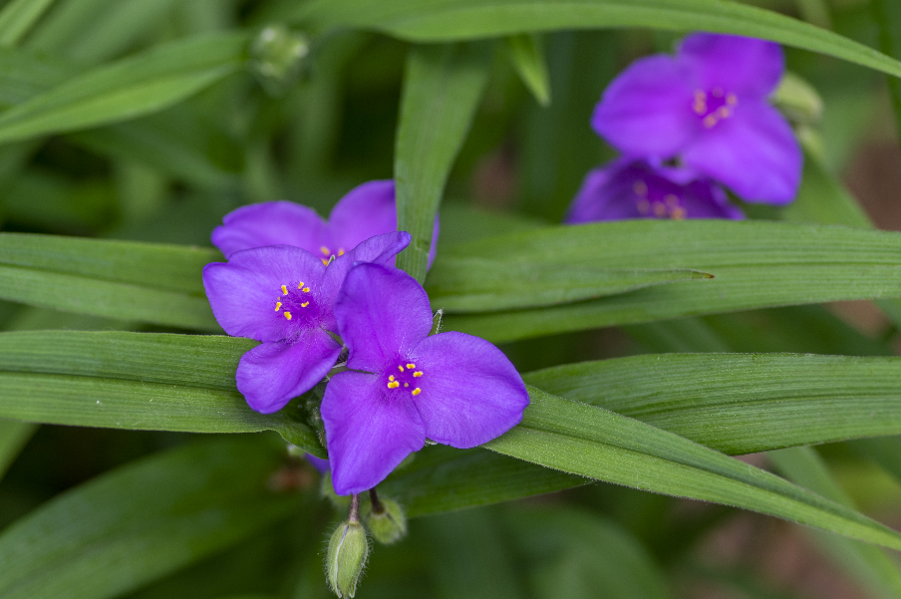


Spiderwort
Tradescantia occidentalis
Shade Plant

Native to Alabama

