
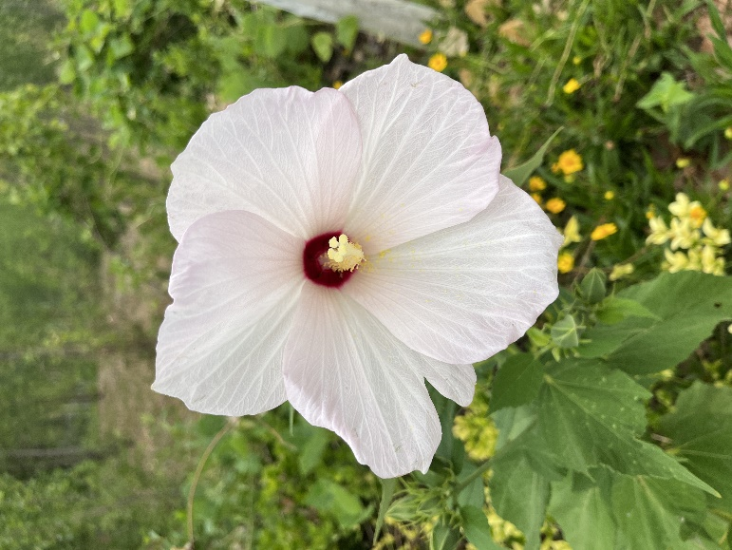
Swamp
Rosemallow
Hibiscus grandifloras
Host & Nectar
Plant
Native to Alabama

