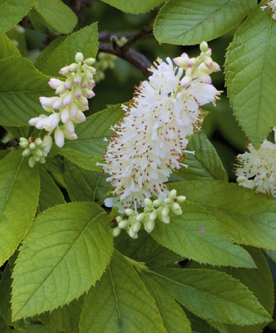

Sweet Pepperbush
Clethra alnifolia
Nectar &
Seeds for Birds

Native to Alabama

