
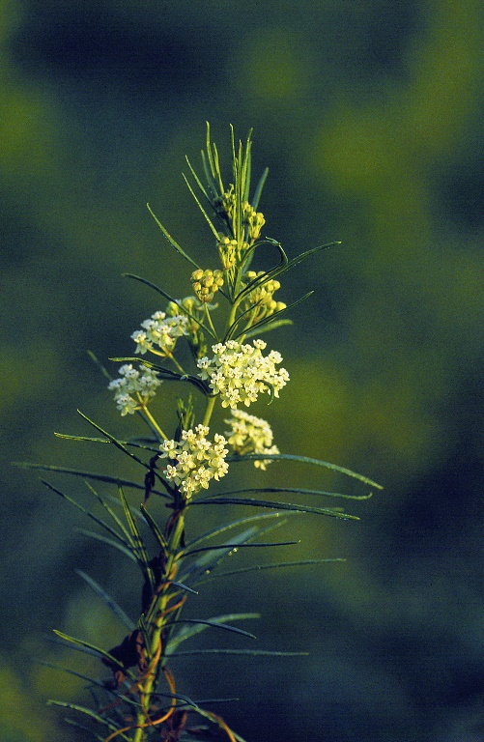

Whorled Milkweed
Asclepias verticillata
Nectar & Host
Plant

Native to Alabamac

