

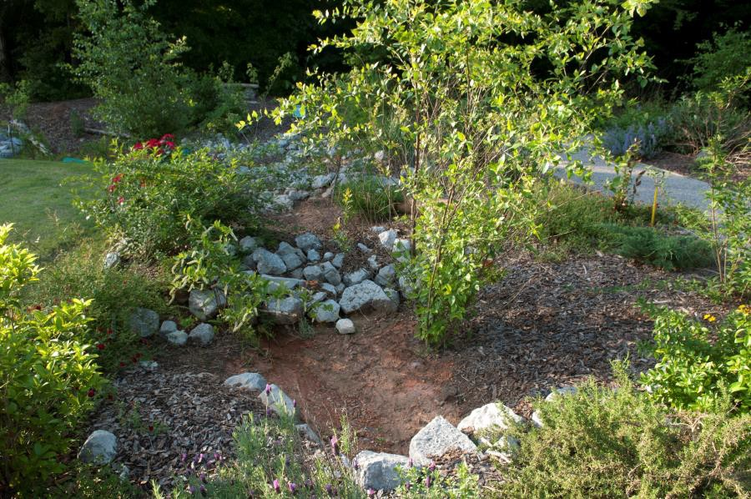
Outdoor Classroom Construction Instructions:
RAIN GARDEN
A Rain Garden, essentially, is a miniature watershed. At the low point of a dry creek bed or spillway, capturing runoff from hard surfaces (roof, driveway, concrete, asphalt, etc.), a rain garden slows flow and allows rain water to be absorbed into the soil close to where the rain falls and helps to recharge groundwater instead of allowing the runoff to flow downhill to become a destructive force elsewhere. Often, stormwater overwhelms municipal sewer drains, picking up pollutants as it flows, and reaching streams and creeks where it causes more havoc such as erosion problems, sediment pollution, and nutrient pollution (nitrogen from fertilizers and from sewage). These things ultimately cause perils to our drinking water and to wildlife inhabiting the waterways.
Use this environmental concept to mitigate water issues in the schoolyard and create a wildlife habitat at the same time. Plant native plants that are specific to local riparian zones to act as filters, to serve a function of holding the soil in place, and the plants will also serve a greater purpose as the foundation of the food web for wildlife. Riparian plants for a rain gardens might include buttonbush, wax myrtle, elderberry, Virginia sweetspire, inkberry, swamp dogwood, juncus grass, sedges and rushes, cinnamon fern, Joe Pye weed, ironweed, swamp sunflower, golden Alexander, cardinal flower, and rose mallow.
- Location Choice Suggestions:
❑ Low-lying, Moist Area OR Near a Spigot, Downspout, Parking Lot, or Drainage Area (so that you can divert water into the rain garden or water the garden during low rain level)
❑
❑
❑
Flat, Horizontal Area along or at the bottom of a spillway (to slow flow of runoff during rain)
Area Approved for Digging (must not have any utility lines in the area)
Full Sun or Full Shade (be sure to choose the appropriate plants based on your sunlight conditions)
❖
Example Rain Garden:
Alabama Wildlife Federation Outdoor Learning Station Construction Instructions: Rain Garden
Page 1 | 3

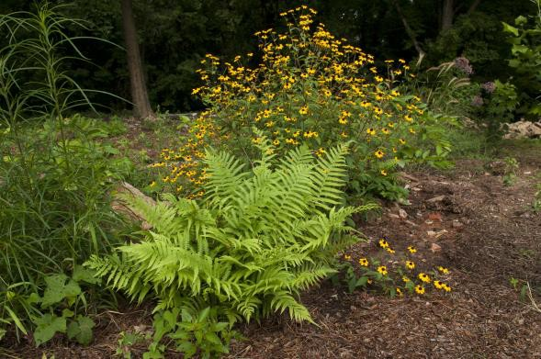
OC Construction Instructions: Rain Garden
❖
Rain Garden Plant suggestions:
Customized plant identification signs with unique QR Codes that you can scan to open plant species’ webpages on AWF's website are available for the bolded species below. The webpages provide specific information about that plant species including a description of the plant, the ecological benefits that species provides, maintenance tips, and photos of the plant including its leaves, flowers & seeds.
❖
Tools, Materials & Supplies:
- (8) Shovels (4 for adults & 4 for children)
- (1) Pick ax for removal of large stones if necessary
- (2-4) Wheelbarrows for moving dirt, coco coir and sand
- (30) ½ gal – 1 gal Buckets or Milk jugs with handles for students to move dirt out of excavated bog area and to put coco coir and sand into the bog garden
- Construction Instructions:
- Procure the tools, materials & supplies, and have them on-hand the morning of your “Build a Rain Garden (or Outdoor Classroom) Day”.
- Measure 11 ft x 18 ft rectangle for large rain garden, (or 8ft x 11 ft for medium or 5 ft x 8 ft for small) and mark boundaries of rectangle with landscaping spray paint; then draw shape of Rain Garden that fits within the rectangle using the landscaping spray paint.
- Dig a shallow depression (6” – 10,” or a series of depressions up to 18”) inside the spray-painted rain garden retention area. Move the excavated soil to the perimeter to build a berm.
- Connect a sloping channel for incoming water. Run water through the spillway with a hose to make sure the grade of the channel is right and that rain will reach the retention area.
Alabama Wildlife Federation Outdoor Learning Station Construction Instructions: Rain Garden
Page 2 | 3
Rain Garden Plants

Ferns, Swamp Sunflower, and Black-eyed Susan

Rain Garden Plants
Bee balm
Buttonbush
Blue flag iris
Wax Myrtle
Blue lobelia
Virginia Sweetspire
Ironweed
Inkberry
Cardinal Flower
Elderberry
Jewelweed
Swamp Dogwood
Joe Pye weed
Spicebush
Swamp Sunflower
Pawpaw
Golden Alexander
Cinnamon Fern
Rose Mallow
Sedges and Rushes
Swamp milkweed

Juncus Grass

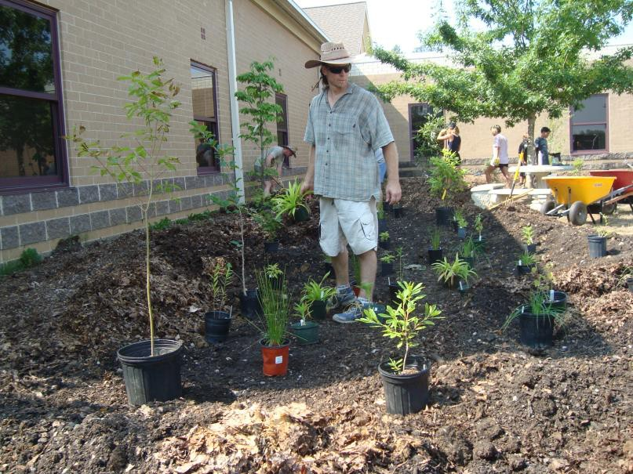
OC Construction Instructions: Rain Garden
❖
Construction Instructions (cont.):
5) Add sand, topsoil, and composted manure or leaves to retention site and to berm to amend the soil. Rake in and mix the soils well. Reserve some of the ingredients to make a soil mixture to add to holes when planting.
- Add rocks or logs (optional) to create nooks and to help direct water flow and help stabilize plantings.
- According to the needs of each plant, plant the plants high on the berm for dryer conditions, and in the depression for wetter conditions. Add soil mixture to each hole to improve soil for each planting. Top with the native soil (excavated soil from hole) and compact soil around each plant. Place plant identification signs in front of plants.
- Top off the garden with composted leaves.
- Optional: Install Rain Barrel on downspout near the Rain Garden, and attach a soaker hose to the rain barrel to funnel rain water into the garden. See the Rain Barrel Project Plan under the
Outdoor Classroom Learning Stations section on the Alabama Wildlife Federation’s website (alabamawildlife.org) for details.
❖
Maintenance Guidelines:
❑
❑
❑
Keep the Rain Garden watered (about once a week) to establish plantings. Mulch in winter as needed. Prune as needed in the winter months.
Pull weeds in May when most of the flowers should be starting to bloom so that you can more easily identify the good plants you planted from the undesirable weeds.
Each season, check the plant identification signs, and update signs that may be difficult to read. Never fertilize.
Each season, update the Rain Garden Kiosk to let other classes know “What’s Growing On…” and to educate the students about the importance of riparian zones in our ecosystems.
❑
❑
❑
Alabama Wildlife Federation Outdoor Learning Station Construction Instructions: Rain Garden
Page 3 | 3

