

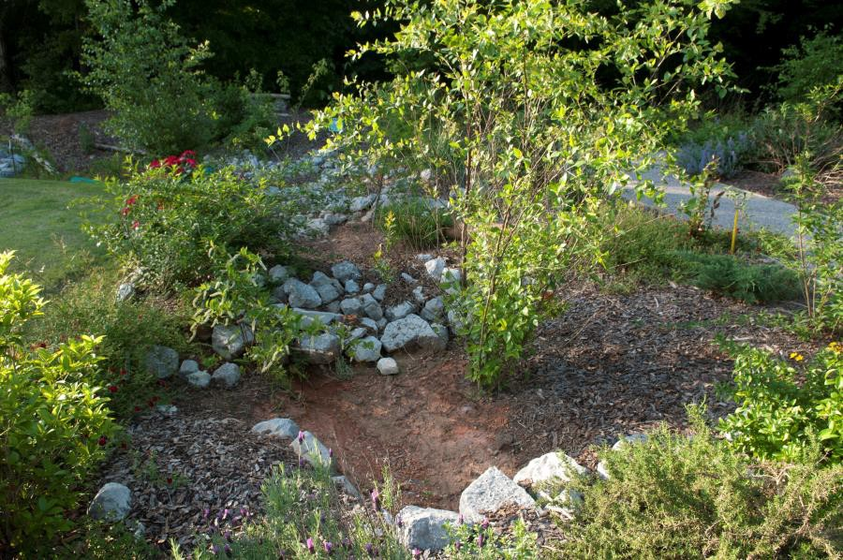
Outdoor Classroom Materials Budget:
RAIN GARDEN
A Rain Garden, essentially, is a miniature watershed. At the low point of a dry creek bed or spillway, capturing runoff from hard surfaces (roof, driveway, concrete, asphalt, etc.), a rain garden slows flow and allows rain water to be absorbed into the soil close to where the rain falls and helps to recharge groundwater instead of allowing the runoff to flow downhill to become a destructive force elsewhere. Often, stormwater overwhelms municipal sewer drains, picking up pollutants as it flows, and reaching streams and creeks where it causes more havoc such as erosion problems, sediment pollution, and nutrient pollution (nitrogen from fertilizers and from sewage). These things ultimately cause perils to our drinking water and to wildlife inhabiting the waterways.
Use this environmental concept to mitigate water issues in the schoolyard and create a wildlife habitat at the same time. Plant native plants that are specific to local riparian zones to act as filters, to serve a function of holding the soil in place, and the plants will also serve a greater purpose as the foundation of the food web for wildlife. Riparian plants for a rain gardens might include buttonbush, wax myrtle, elderberry, Virginia sweetspire, inkberry, swamp dogwood, juncus grass, sedges and rushes, cinnamon fern, Joe Pye weed, ironweed, swamp sunflower, golden Alexander, cardinal flower, and rose mallow.
- Location Choice Suggestions:
  - Low-lying, Moist Area OR Near a Spigot, Downspout, Parking Lot, or Drainage Area (so that you can divert water into the rain garden or water the garden during low rain level)
❑
❑
❑
Flat, Horizontal Area along or at the bottom of a spillway (to slow flow of runoff during rain)
Area Approved for Digging (must not have any utility lines in the area)
Full Sun or Full Shade (be sure to choose the appropriate plants based on your sunlight conditions)
❖
Example Rain Garden:
Alabama Wildlife Federation Outdoor Learning Station Materials List & Budget: Rain Garden
Page 1 | 5

OC Materials List & Budget: Rain Garden
❖
Estimated Costs:
- Small Rain Garden (5 ft x 8 ft → ~40 cu ft): $1,155
- Medium Rain Garden (8 ft x 11 ft → ~75 cu ft): $1,405
- Large Rain Garden (11 ft x 18 ft → ~165 cu ft): $2,010
Materials & Supplies Lists with Estimated Budgets:
❖
Alabama Wildlife Federation Outdoor Learning Station Materials List & Budget: Rain Garden
Page 2 | 5
Example 5 ft x 8 ft x 10 in (~40 cubic ft.) Rain Garden
Station

Materials & Supplies

Est. Cost

Example Materials

Final Cost
Sm. Rain Garden
(1) Can of Rust-Oleum Professional White Water- based Marking Paint @ ~$9.98 ea
$10
Lowe’s Item #429750

Sm. Rain Garden
(1) 6’x50’ Sta-Green Professional Landscape Fabric
(weed barrier) (16’ used for this garden) @~$33.98 ea
$35
Lowe’s Item #510606

Sm. Rain Garden
(12) 1 CF/32 Qt Bags of Evergreen Organic Top Soil @~$2.18 each
$25 total
Lowe’s Item #648834

Sm. Rain Garden
(33) 0.5 CF Bags of All Purpose Sand @~$5.18 ea
$170 total
Lowe’s Item #104898

Sm. Rain Garden
(3) 1 CF Bags of Evergreen Organic Compost and Manure @~$3.68 ea
$10 total
Lowe’s Item #380606

Sm. Rain Garden
(1) 2 CF Bags of Evergreen Organic Drainage and Aeration Soil Conditioner @~$4.58 ea
$5
Lowe’s Item #648829

Sm. Bog
(1) 3/8-in x 25-ft-Element Kink Free Rubber Black Soaker Hose @ ~$15.98 ea
$15
Lowe’s Item #2626704

Sm. Rain Garden
(1) 50-gallon RTS Home Accents Flat Back Brown Rain Barrel (*optional – helps slow flow of rain water and holds water for future watering) @ ~$209.00 ea

$210

Lowe’s Item #4057929

Sm. Rain Garden

(1) RTS Home Accents Black Rain Barrel Stand - (*optional – helps elevate spigot to increase water flow out of barrel and allow for room for buckets to catch water coming out of barrel) @ ~$72.98 ea

$75

Lowe’s Item #4057926

Sm. Rain Garden
(1) 5/8-in x 6-ft FLEXON Light-Duty Vinyl Green Hose @ ~$11.98 ea
$10

Lowe’s Item #812743

Sm. Bog

(1) Universal Diverter System (EarthMinded FlexiFit) (to divert downspout water into rain barrel) @~$35.95 ea

$35

https://www.therainbarreldepo t.com/earthminded-universal- diverter-system/

Sm. Rain Garden
(12) Rain Garden Plants (3 different species with 4 of each species) @ ~$7 ea
$85 total
Nursery via OC Consultant

Sm. Rain Garden
(1) Part of One Ton Pallet of Large Landscape Rock for border (shared with rain garden and frog and toad habitat)
$350
Hardware Store via OC Consultant

OC Materials List & Budget: Rain Garden
- Materials & Supplies Lists with Estimated Budgets (cont.):
Alabama Wildlife Federation Outdoor Learning Station Materials List & Budget: Rain Garden
Page 3 | 5
Example 8 ft x 11 ft x 10 in (~75 cubic ft.) Rain Garden
Station

Materials & Supplies

Est. Cost

Example Materials

Final Cost
Md. Rain Garden
(1) Can of Rust-Oleum Professional White Water- based Marking Paint @ ~$9.98 ea
$10
Lowe’s Item #429750

Md. Rain Garden
(1) 6’x50’ Sta-Green Professional Landscape Fabric
(weed barrier) (16’ used for this garden) @~$33.98 ea
$35
Lowe’s Item #510606

Md. Rain Garden
(26) 1 CF/32 Qt Bags of Evergreen Organic Top Soil @~$2.18 each
$55 total
Lowe’s Item #648834

Md. Rain Garden
(64) 0.5 CF Bags of All Purpose Sand @~$5.18 ea
$330 total
Lowe’s Item #104898

Md. Rain Garden
(7) 1 CF Bags of Evergreen Organic Compost and Manure @~$3.68 ea
$25 total
Lowe’s Item #380606

Md. Rain Garden
(4) 2 CF Bags of Evergreen Organic Drainage and Aeration Soil Conditioner @~$4.58 ea
$20 total
Lowe’s Item #648829

Md. Rain Garden
(1) 50-gallon RTS Home Accents Flat Back Brown Rain Barrel (*optional – helps slow flow of rain water and holds water for future watering) @ ~$209.00 ea

$210

Lowe’s Item #4057929

Md. Rain Garden

(1) RTS Home Accents Black Rain Barrel Stand - (*optional – helps elevate spigot to increase water flow out of barrel and allow for room for buckets to catch water coming out of barrel) @ ~$72.98 ea

$75

Lowe’s Item #4057926

Sm. Rain Garden
(3) Plant ID Signs (one for each plant species) @~$6 ea
$20 total
https://www.alabamawildlife.org/o c-dig-into-plants/ for details

Sm. Rain Garden
(3) Biomarkers to hold Plant ID signs (13” stake with a 2” x 4” plate) @ ~$3 ea (includes S&H)

$10 total

AWF OC Consultant or https://mcgbiomarkers.com/sho p/

Sm. Rain Garden
(1) 18” x 24” .80 Aluminum Sign (with educational information about rain gardens)

$75

Ask OC Consultant about https://www.alabamawildlife.o rg/oc-signs/

Sm. Rain Garden
(1) 6 ft. U-Post for Fence (for educational sign)
@~$10.69 ea
$10
Lowe’s Item #493054

Sm. Rain Garden
(1) Hillman 1/4-in x 1-1/2 in Zinc-Plated Coarse Thread Hex Bolt (2-count) @~$0.88 ea

$5 total

Lowe’s Item #137634

Sm. Rain Garden
(2) Hillman 1/4-in x 20 Zinc-Plated Steel Hex Nut @~$0.10 ea
Lowes Item #63301

Sm. Rain Garden
(2) Hillman 1/4-in Zinc-Plated Standard Flat Washer @~$0.15 ea
Lowe’s Item #63306

TOTAL ESTIMATED COST: $1,155

OC Materials List & Budget: Rain Garden
- Materials & Supplies Lists with Estimated Budgets (cont.):
Alabama Wildlife Federation Outdoor Learning Station Materials List & Budget: Rain Garden
Page 4 | 5
Example 11 ft x 18 ft x 10 in (~165 cubic ft.) Rain Garden
Station

Materials & Supplies

Est. Cost

Example Materials

Final Cost
Lg. Rain Garden
(1) Can of Rust-Oleum Professional White Water- based Marking Paint @ ~$9.98 ea
$10
Lowe’s Item #429750

Lg. Rain Garden
(1) 6’x50’ Sta-Green Professional Landscape Fabric
(weed barrier) (16’ used for this garden) @~$33.98 ea
$35
Lowe’s Item #510606

Lg. Rain Garden
(58) 1 CF/32 Qt Bags of Evergreen Organic Top Soil @~$2.18 each
$125 total
Lowe’s Item #648834

Lg. Rain Garden
(148) 0.5 CF Bags of All Purpose Sand @~$5.18 ea
$765 total
Lowe’s Item #104898

Lg. Rain Garden
(15) 1 CF Bags of Evergreen Organic Compost and Manure @~$3.68 ea
$55 total
Lowe’s Item #380606

Md. Rain Garden
(1) 5/8-in x 6-ft FLEXON Light-Duty Vinyl Green Hose @ ~$11.98 ea
$10
Lowe’s Item #812743

Md. Rain Garden
(1) Universal Diverter System (EarthMinded FlexiFit) (to divert downspout water into rain barrel) @~$35.95 ea

$35

https://www.therainbarreldepot
.com/earthminded-universal- diverter-system/

Md. Rain Garden
(18) Rain Garden Plants (3 different species with 6 of each species) @ ~$7 ea
$130 total
Nursery via OC Consultant

Md. Rain Garden
(1) Part of One Ton Pallet of Large Landscape Rock for border (shared with rain garden and frog and toad habitat)
$350
Hardware Store via OC Consultant

Md. Rain Garden
(3) Plant ID Signs (one for each plant species) @~$6 ea
$20 total
https://www.alabamawildlife.org/o c-dig-into-plants/ for details

Md. Rain Garden
(3) Biomarkers to hold Plant ID signs (13” stake with a 2” x 4” plate) @ ~$3 ea (includes S&H)

$10 total

AWF OC Consultant or https://mcgbiomarkers.com/sho p/

Md. Rain Garden
(1) 18” x 24” .80 Aluminum Sign (with educational information about rain gardens)

$75

Ask OC Consultant about https://www.alabamawildlife.o rg/oc-signs/

Md. Rain Garden
(1) 6 ft. U-Post for Fence (for educational sign)
@~$10.69 ea
$10
Lowe’s Item #493054

Md. Rain Garden
(1) Hillman 1/4-in x 1-1/2 in Zinc-Plated Coarse Thread Hex Bolt (2-count) @~$0.88 ea

$5 total

Lowe’s Item #137634

Md. Rain Garden
(2) Hillman 1/4-in x 20 Zinc-Plated Steel Hex Nut @~$0.10 ea
Lowes Item #63301

Md. Rain Garden
(2) Hillman 1/4-in Zinc-Plated Standard Flat Washer @~$0.15 ea
Lowe’s Item #63306

TOTAL ESTIMATED COST: $1,405

OC Materials List & Budget: Rain Garden
- Materials & Supplies Lists with Estimated Budgets (cont.):
Alabama Wildlife Federation Outdoor Learning Station Materials List & Budget: Rain Garden
Page 5 | 5
Lg. Rain Garden
(9) 2 CF Bags of Evergreen Organic Drainage and Aeration Soil Conditioner @~$4.58 ea
$40 total
Lowe’s Item #648829

Lg. Rain Garden
(1) 50-gallon RTS Home Accents Flat Back Brown Rain Barrel (*optional – helps slow flow of rain water and holds water for future watering) @ ~$209.00 ea

$210

Lowe’s Item #4057929

Lg. Rain Garden

(1) RTS Home Accents Black Rain Barrel Stand - (*optional – helps elevate spigot to increase water flow out of barrel and allow for room for buckets to catch water coming out of barrel) @ ~$72.98 ea

$75

Lowe’s Item #4057926

Lg. Rain Garden
(1) 5/8-in x 6-ft FLEXON Light-Duty Vinyl Green Hose @ ~$11.98 ea
$10

Lowe’s Item #812743

Lg. Rain Garden
(1) Universal Diverter System (EarthMinded FlexiFit) (to divert downspout water into rain barrel) @~$35.95 ea

$35

https://www.therainbarreldepot
.com/earthminded-universal- diverter-system/

Lg. Rain Garden
(24) Rain Garden Plants (4 different species with 6 of each species) @ ~$7 ea
$170 total
Nursery via OC Consultant

Lg. Rain Garden
(1) Part of One Ton Pallet of Large Landscape Rock for border (shared with rain garden and frog and toad habitat)
$350
Hardware Store via OC Consultant

Lg. Rain Garden
(4) Plant ID Signs (one for each plant species) @~$6 ea
$25 total
https://www.alabamawildlife.org/o c-dig-into-plants/ for details

Lg. Rain Garden
(4) Biomarkers to hold Plant ID signs (13” stake with a 2” x 4” plate) @ ~$3 ea (includes S&H)

$15 total

AWF OC Consultant or https://mcgbiomarkers.com/sho p/

Lg. Rain Garden
(1) 18” x 24” .80 Aluminum Sign (with educational information about rain gardens)

$75

Ask OC Consultant about https://www.alabamawildlife.o rg/oc-signs/

Lg. Rain Garden
(1) 6 ft. U-Post for Fence (for educational sign)
@~$10.69 ea
$10
Lowe’s Item #493054

Lg. Rain Garden
(1) Hillman 1/4-in x 1-1/2 in Zinc-Plated Coarse Thread Hex Bolt (2-count) @~$0.88 ea

$5 total

Lowe’s Item #137634

Lg. Rain Garden
(2) Hillman 1/4-in x 20 Zinc-Plated Steel Hex Nut @~$0.10 ea
Lowes Item #63301

Lg. Rain Garden
(2) Hillman 1/4-in Zinc-Plated Standard Flat Washer @~$0.15 ea
Lowe’s Item #63306

TOTAL ESTIMTED COST: $2,010

